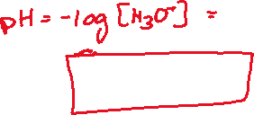

The nitric acid contributes more to the pH of acid rain. As can be seen in Parts B and C, nitric acid is the stronger of the two acids. The stability of the nitrate ion and lack of Ka value, indicates that the nitric acid dissociates more in water producing a higher concentration of H3O+. Part D further corroborates this determination. Nitric acid contributes a concentration of 3x10-3 M H3O+ while nitrous acid contributes a concentration of 9.55x10-4 M H3O+.